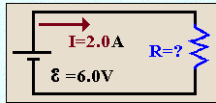

**Question**   
The current flowing in a circuit containing four resistors connected in series is **I = 1.0 A**. The potential drops across the first, second and third resistors are, respectively: **V = 5 V**, **V = 8 V**and **V = 7 V**.   
The equivalent resistance of the circuit is **R = 30https://www.physics.uoguelph.ca/tutorials/ohm/omega.gif**

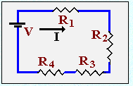

**Question**

 In the following schematic diagram, find the total current, I.

